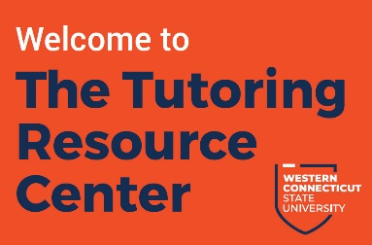
Tutoring Resource Center
Job Description: Peer Tutor

Peer Tutors work under the direct supervision of the coordinator of the Tutoring Resource Center. Tutors are responsible for providing WCSU students with the instruction and support necessary to achieve their educational goals and to help students develop effective learning habits. Tutors are exceptional students who are skilled in a subject/content area, possess a love of learning, great academic skills and habits, and enjoy helping and teaching others.

PRIMARY DUTIES AND RESPONSIBILITIES

- Conduct individual and small group tutoring sessions for WCSU students in the TRC
- Promote independent learning among clients
- Reinforce key concepts presented by each student’s professor
- Promote academic integrity among clients
- Track attendance of all clients
- Report clients who may require assistance from other programs to the TRC Coordinator
- Maintain the confidentiality of students and promote a safe environment for learning
- Attend mandatory tutor training workshops and meetings
- Maintain timely communication by email or other designated methods with TRC staff
- Perform other necessary duties related to the tutoring function as assigned by the TRC Coordinator

ESSENTIAL ABILITIES
- Communicate effectively with university faculty, staff, students, and guests
- Exhibit helpful attitude towards all students and WCSU staff
- Promote appropriate learning strategies for a variety of learning styles
- Maintain accurate records and submit Client Report Forms in a timely manner
- Make decisions and work independently
- Ensure policies and procedures are followed at all times
- Exhibit good customer service skills
- Work collaboratively and productively with peers

QUALIFICATIONS

Applicants must be currently enrolled at WCSU in a minimum of 6 credits and maintain above a 3.0 cumulative GPA (3.2 or higher preferred). Tutors must have earned a B+ or better in each course they tutor. Tutors must be knowledgeable in their content area, have excellent organizational skills, strong study habits, and a positive attitude towards learning. Tutors must also be able to communicate ideas effectively and concisely to students.

