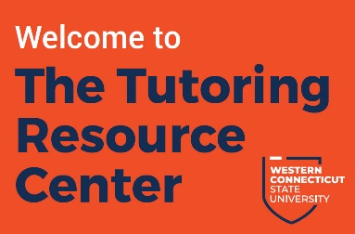
Tutoring Resource Center
Job Description: Center Assistant

The Tutoring Resource Center is looking for a self-motivated, responsible, and customer-service oriented student to represent the Tutoring Resource Center. Center Assistants play a key role in the management of the TRC by greeting and directing students as they enter the TRC, assisting students scheduling appointments, and supporting the TRC Coordinator with daily administrative task and a variety of other projects.

PRIMARY DUTIES AND RESPONSIBILITIES

- Greet students as they enter the TRC
- Direct the flow of traffic into the TRC by connecting students with their assigned tutors or coaches
- Assist students creating appointments & navigating the online scheduling portal MyWCOnline
- Respond to inquiries about TRC services in a professional and supportive manner
- Provide information on other WCSU academic resources and make timely and appropriate referrals
- Assist TRC Coordinator in managing TRC schedules and sending reminder notifications to students
- Maintain a clean and inviting space in the TRC
- Perform daily administrative tasks such as setting up and cleaning up TRC, putting away supplies, checking out TRC supplies to students, refilling printer with paper, and cleaning white boards
- Opportunities to assist TRC with projects, planning TRC events, and social media and marketing materials

ESSENTIAL ABILITIES
- Exhibit a helpful, friendly, and professional attitude towards all students and WCSU staff
- Knowledgeable about WCSU campuses, offices, resources, and policies
- Able to make decisions and work independently
- Ensure policies and procedures are followed at all times
- Excellent customer service skills
- Ability to work collaboratively and productively with peers
- Demonstrate a proactive attitude to seeking projects and learning new skills

QUALIFICATIONS

Applicants must be currently enrolled at WCSU in a minimum of 6 credits and maintain above a 2.7 cumulative GPA. Center Assistants will have excellent organizational skills, communicate effectively with students, faculty, and staff, and be able to work independently while maintaining the highest level of professionalism and integrity.

Work study
$12.00/hr (8-12 hours per week)

