Seventh Tri-State Weather Conference
Saturday, September 29, 2018
Western Connecticut State University, Danbury, CT
Register online by September 1 to ensure your spot:
Gary Lessor, Conference Chair, Western Connecticut State University
lessorg@wcsu.edu
http://wcsu.edu/weatherconference/registration/
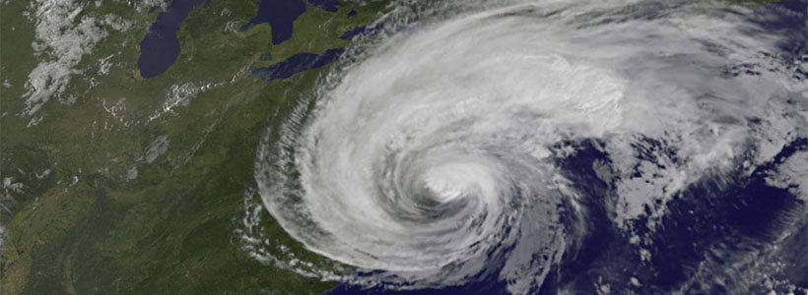
The conference is presented by the Meteorology Program at Western Connecticut State University and co-sponsored by the WestConn Student Chapter of the AMS, the New York City/Long Island Chapter of the AMS, NOAA/National Weather Service/Upton, N.Y and NOAA/National Weather Service/Taunton, MA. The purpose of the conference is to enhance education, professional development and communication among private and public sector meteorologists, researchers, educators, students, emergency management officials, and weather enthusiasts.
Conference link: http://www.wcsu.edu/weatherconference/

